Fantasy LCS Report

**INTRO**

League of Legends is a competitive esports game that pits two teams of five players against each other to destroy the enemy base. Fantasy LCS (FLCS) follows the basic format of fantasy football where fans can draft pros and play against each other in 1v1 matchups each week. Each week, the fan 'plays' one player from each role, a team, and a flex (pro from any role) and points are awarded based on the pro's performance. The scoring is the same regardless of role except for teams, which are evaluated differently. There are two regions to draw from, North America (NA) and Europe (EU), consisting of 10 teams.

**TEAMS**

Teams are awarded 2 points for a win, 1 point per turret taken, 2 points per baron, 1 point per dragon, 2 points for getting the first kill, and 2 points for winning in under 30 minutes. The minimum number of turrets taken to win the game is 5 but the normal amount is ~9 with a maximum amount of 11. Dragons spawns 2.5 minutes into the game with a 5 minute respawn timer, although taking a dragon requires a certain level of control over the game. Baron requires a lot more control, spawning at 20 minutes with a 7 minute respawn timer.

For a winning team, there is a hard floor of 7 points, but given how close the mandatory objectives are to the total amount of objectives, most wins earn a team ~18 points. While not impossible to lose without earning a single objective, most teams will be able to take at least a few turrets/dragons.

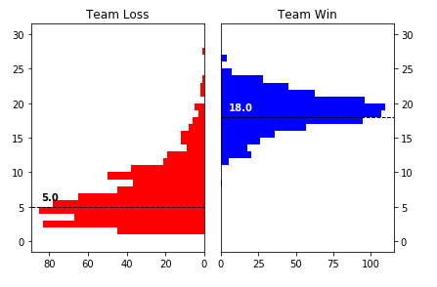

Splits 3-5 were not included as NA used a best of 3 system and EU used a 2 game system (if both teams won a game it counts as a tie).

As is expected, wins are very stable, reliably netting a team 18-19 points. Most losses earn 5 points but there is a noticeable skew to the right. While the clear strategy is to pick a team that will win both games, the next best thing is to find a way to maximize points for a loss.

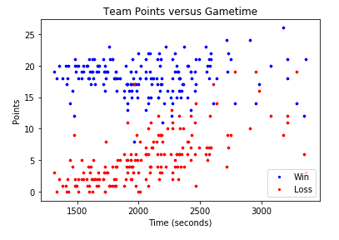

This further demonstrates the basic principle where points for a win is static while there is significant variation in points for a loss. 42% of the variance in the points of a loss can be explained by game time. This is very significant given the high amount of natural variance in games due to the low number of players in a game as well as team compositions (there are 148 different playable characters in the game with a wide range of skills and playstyles). When a game enters 'late game', the deciding factor of who wins becomes closer to a 50/50. This is due to the gold differences meaning much less in proportion to the total amount of gold each team has. Additionally, there is a max number of items any player can buy, so after a certain point extra gold is meaningless. We can see this in the intermingling of wins and losses as the game time increases.

A script was used in order to generate an estimate to the ELO ratings of each team when they played each other. Every team starts off with a rating of 1000 for their first week, regardless if it was during split 1 or 6. However, this ELO rating system is not entirely reliable (new teams will not be at 1000 and teams change drastically from summer to spring split). Therefore, only summer splits with a recorded spring split were used. Additionally, for the first two of these splits, games were best of twos, making retroactively attaching game times to points impossible (points were determined by best score out of all games). Therefore, only split 7 was used to analyze ELO and game time.

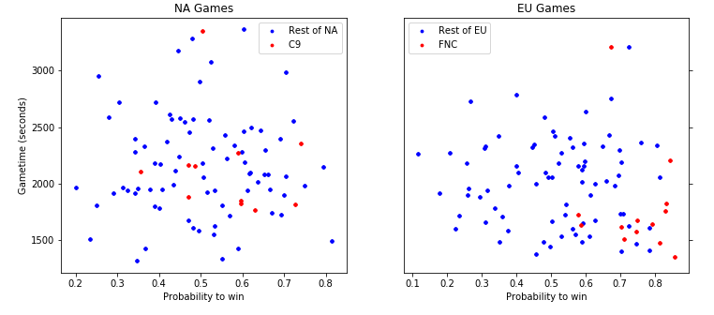

Only wins were used as data would be mirrored about the x=0.5 line (each game has two data points with opposite probabilities to win but the same game time. Surprisingly, the probability to win does not have an effect on either the game time or points earned (not shown but the graph is similar). If all teams were plotted the same color, there would be very little to distinguish the two plots except for a small cluster at the bottom right of the EU graph. C (NA) and Fnatic (EU) were chosen because they had very similar dominance in terms of record and started off the season with a similar ELO rating. Even in games where C9 had a similar probability to win, their games lasted longer than Fnatic's.

Some splits have a very dominate team that beats the others in a very clean and consistent way. This particular season it was Fnatic, last year it was G2, and this year it looks like it will be C9. Identifying/predicting this team is very important as teams losing to Fnatic earned a median of 2 points but teams that beat Fnatic earned a median of 17 for a win. Even though the sample size is small, the pattern is clear that the super team needs to get identified in order to pick/avoid it. Otherwise, picking the team with the highest chance to win both games is optimal.

**PLAYERS**

In contrast to teams, players do not earn points based on winning or on objectives, but through performance. They earn 2 points per kill, 1.5 points for an assist, 0.01 point per cs (players usually get ~200) and lose 0.5 points for dying. Games with a lot of teamfights earn more points for both teams because both sides earn kills and assists (even if a player dies every teamfight, if they get at least one assist they'll earn 1 point per fight). While a winning team usually cannot prevent the losing team from getting a single objective, the team that wins the teamfight is the one that gets to take objectives. Additionally, winning a game does not have a hard floor or soft ceiling in terms of points.

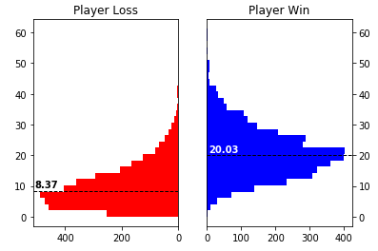

Given that losing players have much more room to earn points than a losing team, and that winning players don't have a guaranteed amount of points, it is not surprising that the variability in the amount of points earned is much higher for players. The disparity between points earned by a winner and loser is less than that for teams, despite the increased variance in points earned. The next graph is very similar to the team graph with the exception that the points are a lot less split between win/loss. Plot 1 demonstrates the convergence of points given messy gameplay and plot 2 illustrates that the binary of win/loss is nowhere near as secure for players as it is for teams.

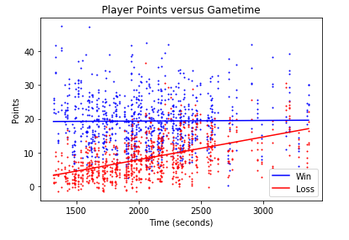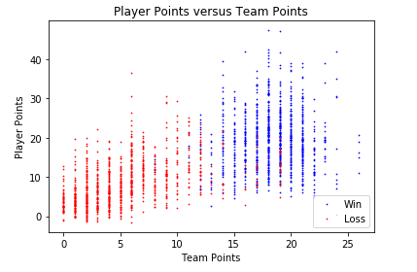

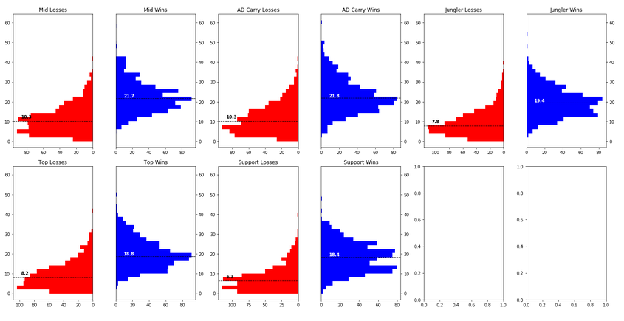

When looking at the differences between positions, two things stand out. First, Mid and AD Carry (adc) earn the most amount of points for both wins and losses. Second, Support has the highest penalty for a loss versus a win.

When picking a flex player (usually the first player picked), it is important to pick an adc or mid from a good team that will win often. The flex player's point differential over the opponent for that week (in fantasy terms) is determined by the overall point spread. Every other position's point differential only matters when looking at the opponent's player of the same position. Therefore, once a stable flex pro has been picked, point gains are calculated by looking at the above graph.

Overall, getting a mid or adc on a top team is the best strategy. After that, it is very important to get a support, then jungler as those two have stronger penalties for losing.

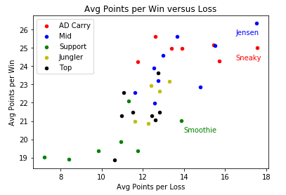

The average points earned per win and loss was found for pro players with more than 100 games. The results were plotted with different positions marked in different colors. Support and AD Carry have high variance in points earned during a loss but are relatively static for a win. Junglers and Top laners don't demonstrate a clear pattern but have higher variance for wins. Mid laners, surprisingly, show a decent positive trend, indicating that good midlaners are more consistent in earning points regardless of how the game is going.

It is not surprising that the two positions that lane together in the bot lane, AD Carry and Support, show a similar pattern in a win/loss analysis. Most team plays, especially after the early game, are done through bot as there are two players there. This means that wins will consistently rack the same amount of points, regardless of player. Mid laners, however, have the highest amount of agency. They can coordinate with the jungler to make 2v2 plays against the enemy mid/jungle, they can roam to either lane, or they can simply outplay their lane opponent. While bad mid laners can get stomped, a great mid laner will be able to positively affect the map no matter how the game is going. Mid laners can earn as much as AD Carries but do so less reliably. A decent ADC is much better than a decent Mid but getting the best Mid is far better than the best ADC.

Team based analysis did not yield enough results. Most teams earn the same amount of points and players on each team earn the same amount of points as other teams. This is largely due to team synergy and the game meta playing a massive role. Surprisingly, the big teams were not sufficiently better than other teams on average, mostly due to them having bad splits. The only team that stood out was C9, but it's hard to tell what is causing that as the best mid and adc from above only played on C9 (after fantasy LCS ended Jensen moved to TL and played better than when on C9). Additionally, the other two roles did not outperform the other teams so the players caused this difference.

**CONCLUSION**

The best strategy is to have the best mid laner possible and best adc as the flex. ADCs provide a stable source of points, so having two adcs on winning teams is ideal. However, if there are no adcs on a top tier team left, a good mid laner on a bad team will be able to maximize the amount of points earned.

Then, getting a support/team that will win the most games would be better. These two positions are the most hurt by losing and these lost points are worse than having a slightly worse adc/mid.

After that, it's picking a top, jungler, and adc on the best team available.